TABLEAU

CERTIFICATION PROJECT



COMPARATIVE STUDY OF COUNTRIES

**Objective: Create a dashboard to compare all the parameters mentioned above for different countries, to strategize market penetration and to target new customers.**

1.Create a geographic map showing the countries' fields. Color the map based on the income column from the secondary dataset

1.Include income group filter in the dashboard

STEP1: Open **Tableau 10.x**

STEP2: On the home page, under **Connect,** under **to a file,** click **Excel.**

STEP3: Browse and connect to the **Global Financial Development Database - Jul2018** Excel file.

STEP4: Drag and drop **Data July 2018** tables to the canvas area.

STEP5: Click on Add button to connect **Insurance Sample Dataset** Excel file. 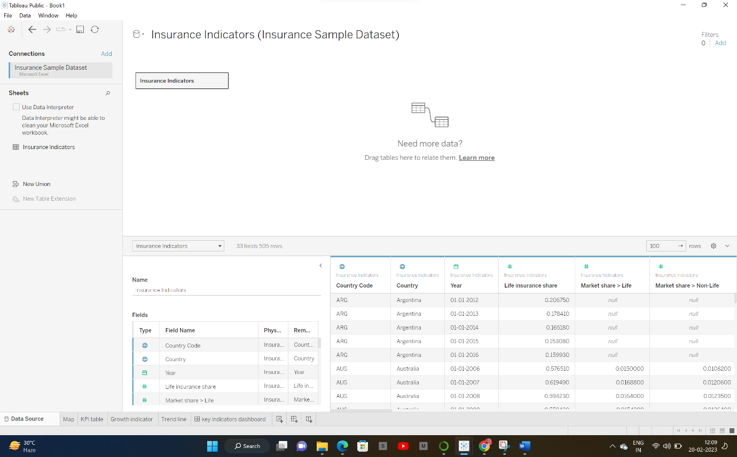

STEP6: Go to Sheet one and rename it as MAP.

STEP7: To Create a **MAP**, drag **Country** from **Insurance Sample Dataset** and put on Detail Mark card and then go to automatic and click map. Then drag Income from **Global Financial Development Database** to filer and select all and click on show filter. Drag **Income** to Colour Mark Card and **Country Code** to text Mark card.

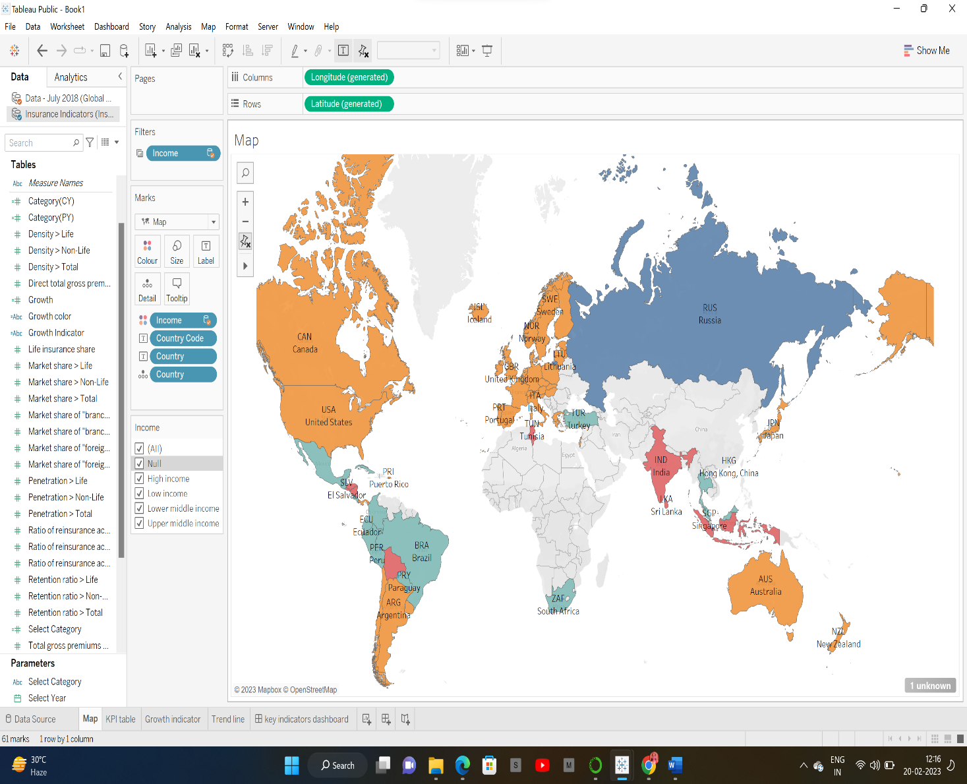

STEP8: Create 2 Parameters , One for **Select Year** and Another **Select Category.**

STEP9: To create Parameter go to Down key below Filter button in Data panel , And click on Create Parameter. For Year parameter click on Date datatype and for Select Category Click on String Data type.

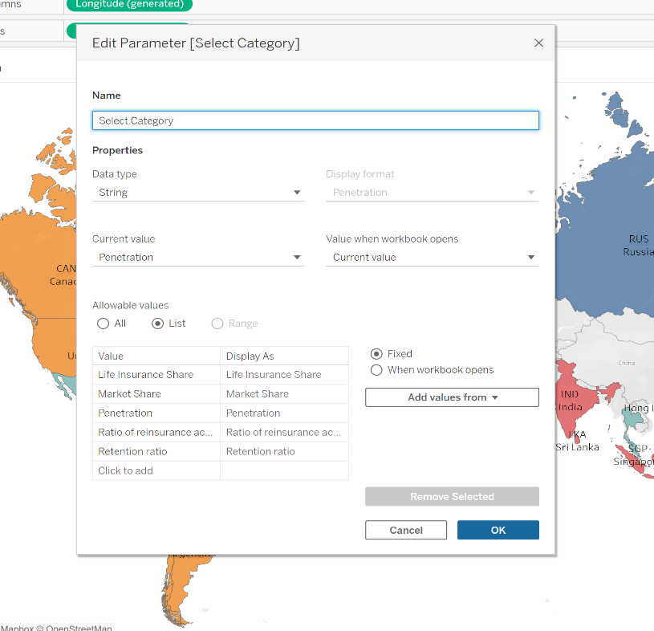

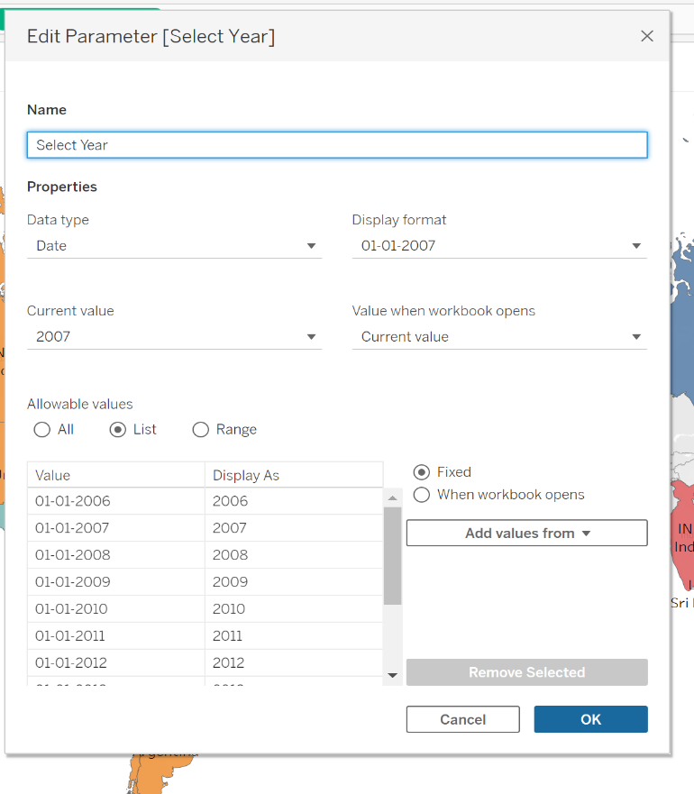

STEP10: Create **CALCULATED FIELD.** To Select

Category, Categorial CY(Current year) and Categorial PY(Previous Year),Growth %.

Click on Analysis Pane , and then Calculated Field and do calculations for the following.

Select Category is for : to Select Category Parameter

Categorial CY: Selected Period Value

Categorial PY : Comparison Period Value

Growth : For Growth % 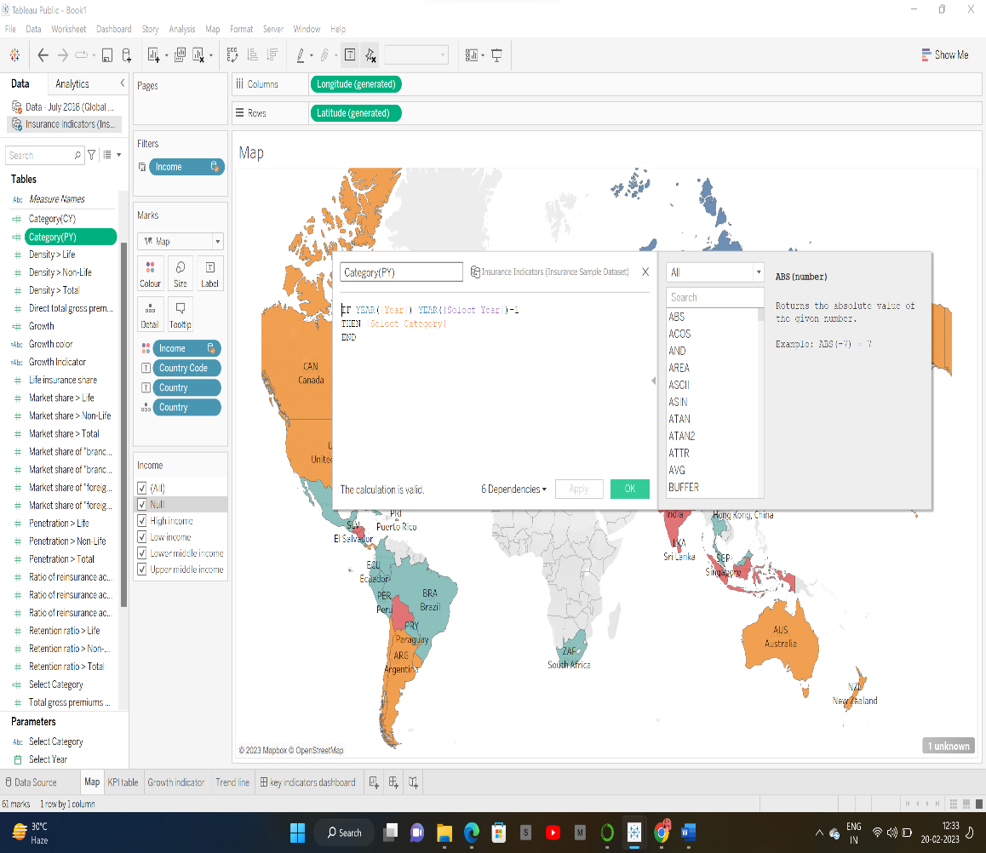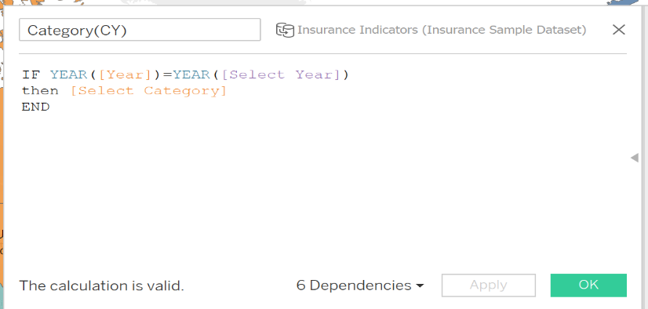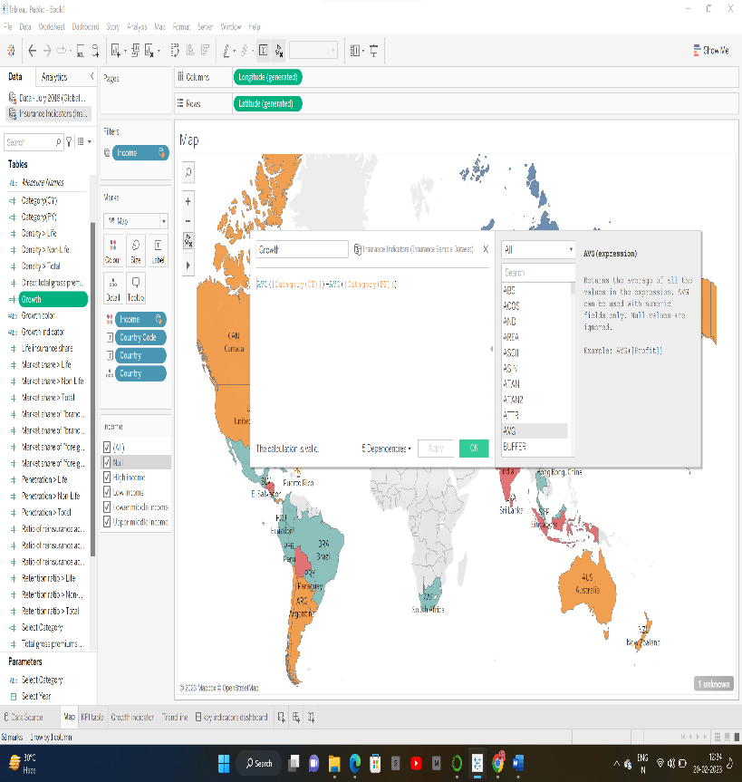

STEP11: Create a **KPI Calculator**: Go to new sheet and rename it KPI table and click on Sheet title and insert Select Category

Click on Parameters and Show Parameter.

Drag Measure Names to Row and filter it to Categorical CY , Categorial PY , Growth. And Measure Values to Text Mark card

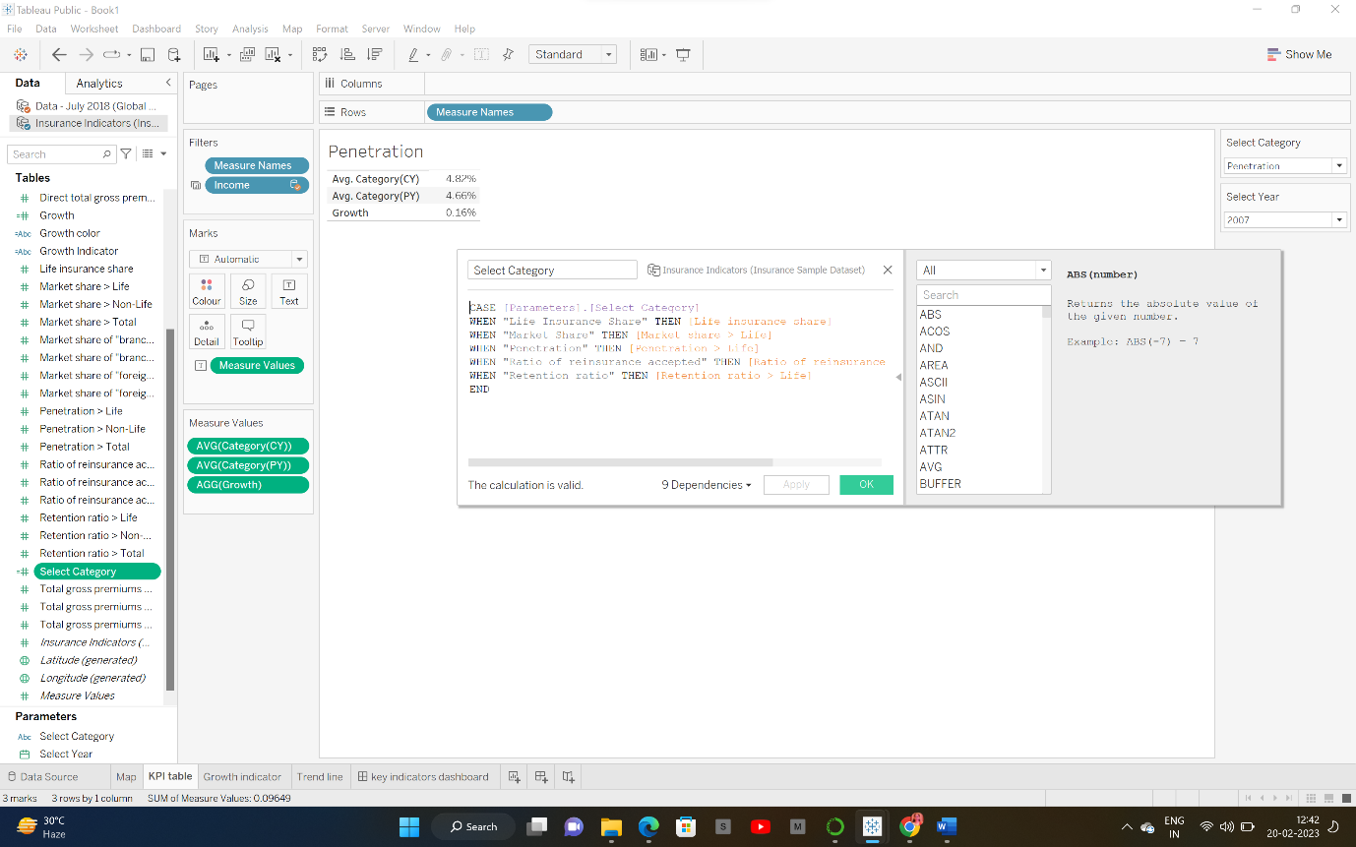

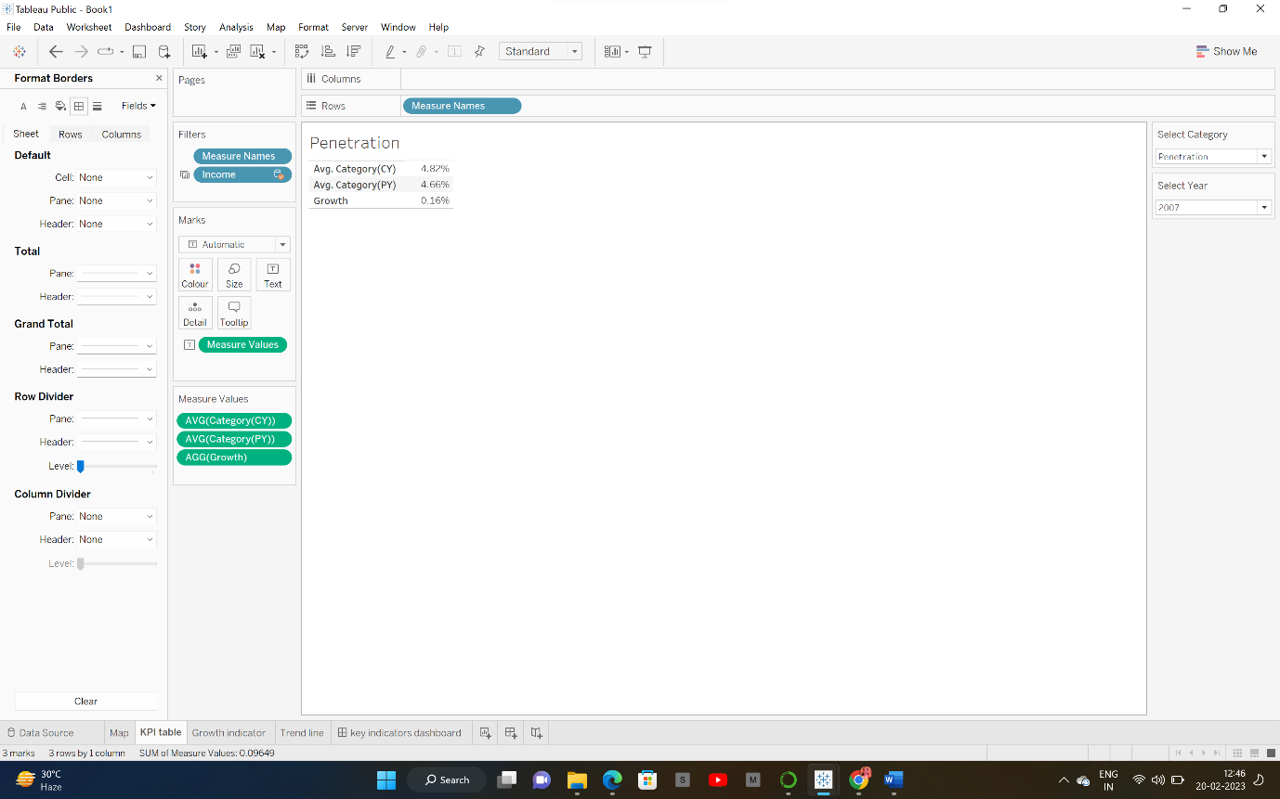

**Step 12:** To create a growth indicator:

Create 2 Calculated Field: Growth Colour and Growth Indicator.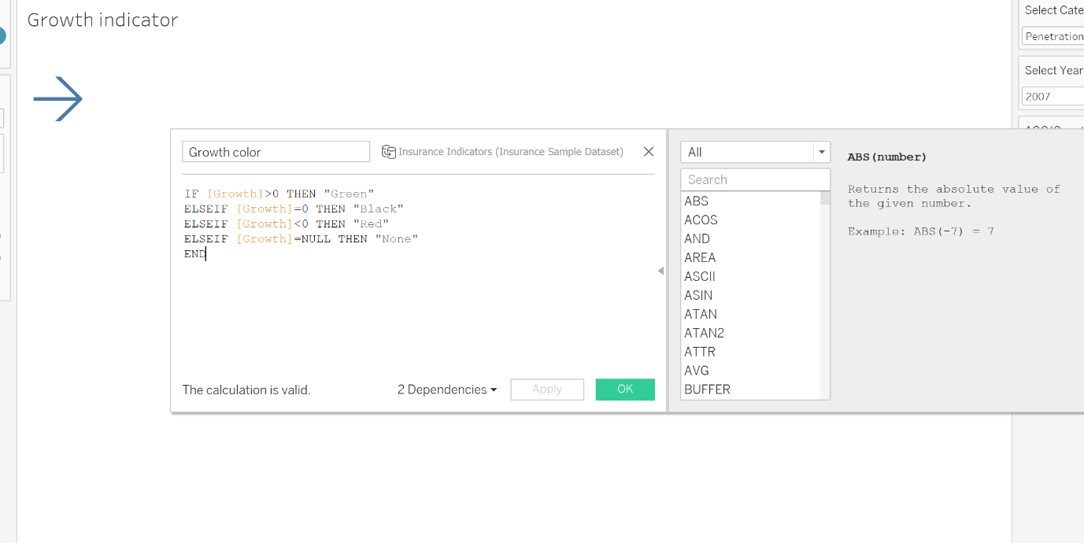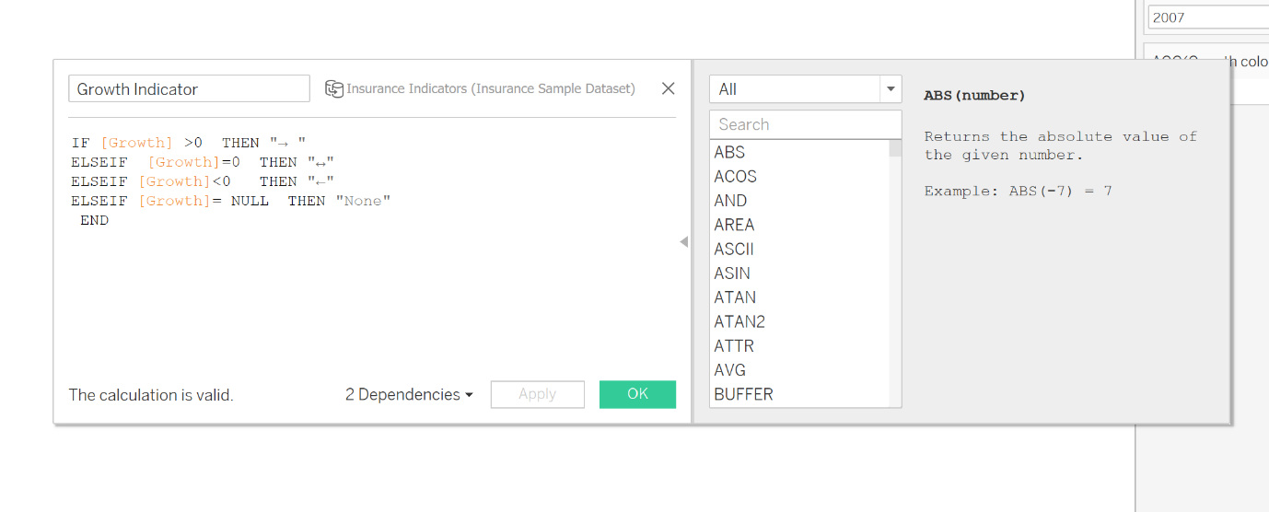

STEP13: Growth Indicator Visualization : Go to New Sheet and rename it Growth Indicator

Click on Parameters and Show Parameter.

Drag Growth Colour to Colour and Growth Indicator To text. 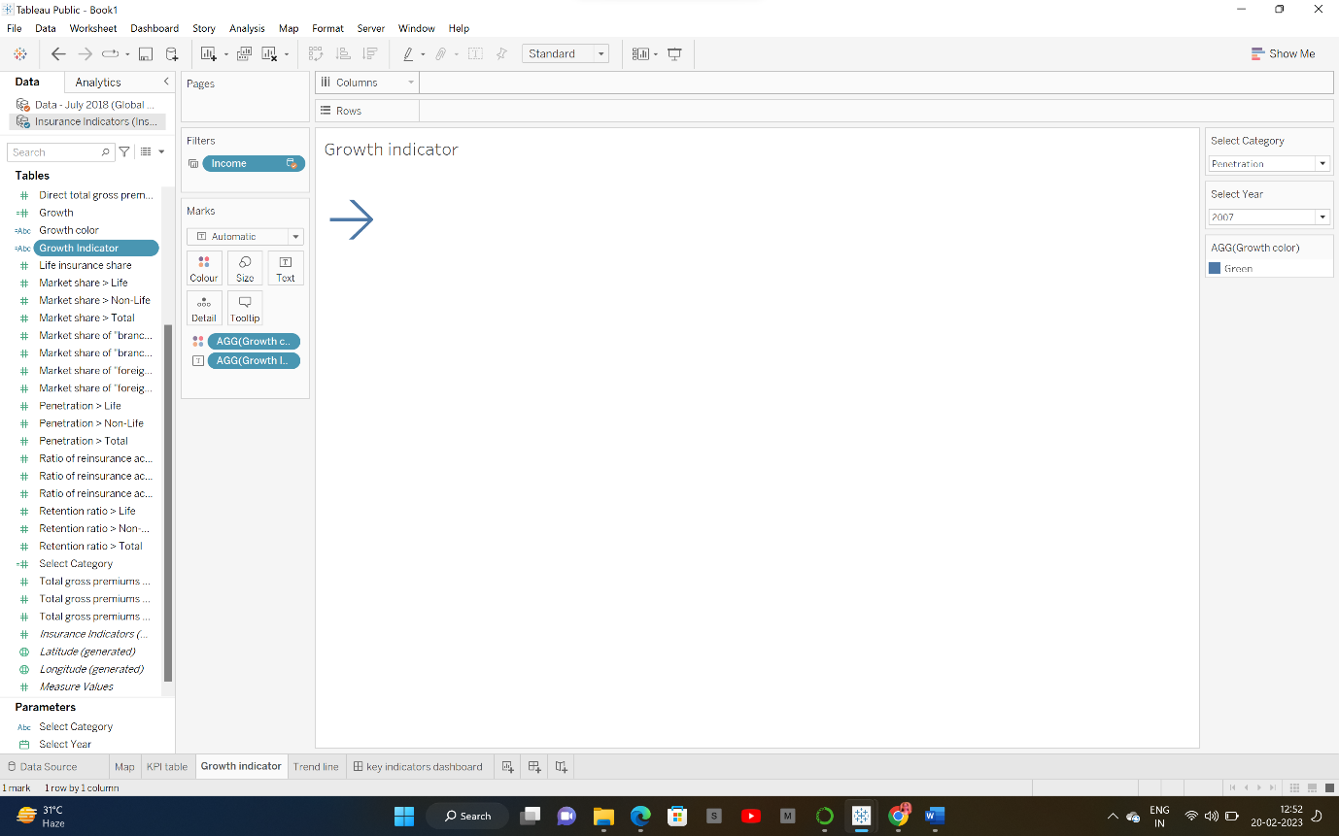

STEP14: To Create Trend Chart: Go to New sheet and rename it Trend Chart.

Click on Parameters and Show Parameter.

Drag Year to Columns and Select Category Measure to Rows.

Year to Pages [To make a Motion Chart] and click on Show history .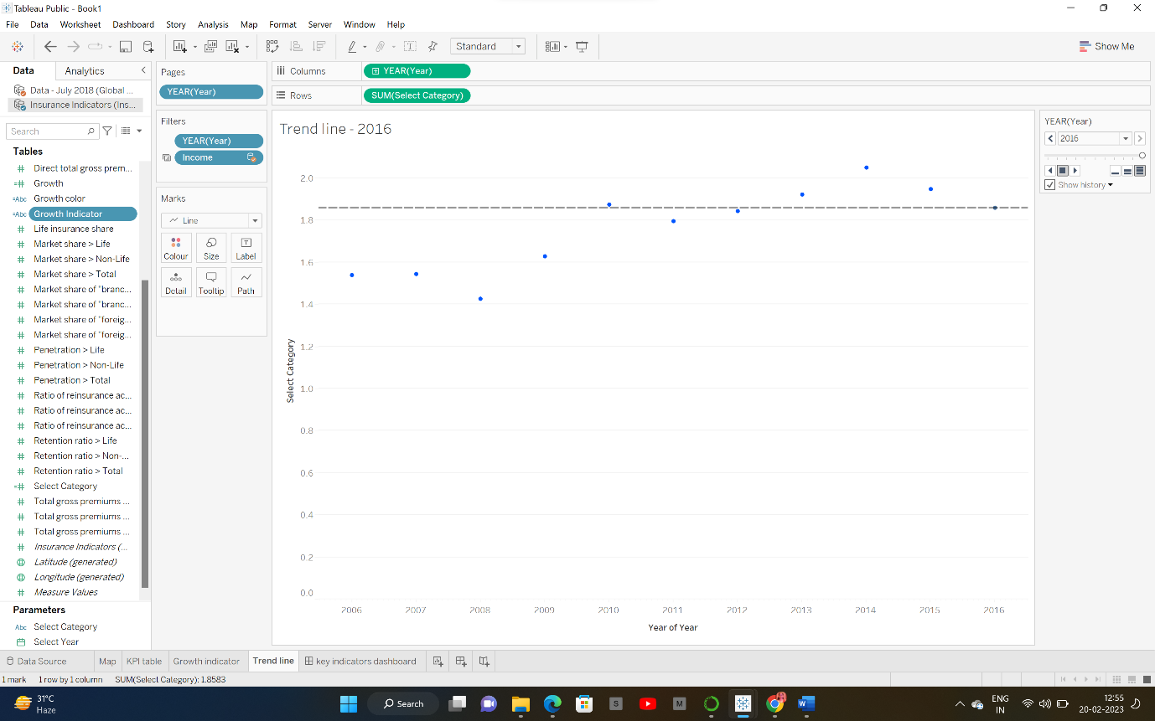

STEP15: Create a Dashboard: Click on Dashboard button .

Go to Size and click Automatic.

Go to Objects and click on Horizontal, Then Vertical , and then Horizontal, Drag Map to sheet , From Objects drag web Page to sheet.

Then Go to Dashboard , Click Action -> add action -> go to URL -> edit action-> Source sheet -> Map and Run action -> Select And add URL in URL bar. 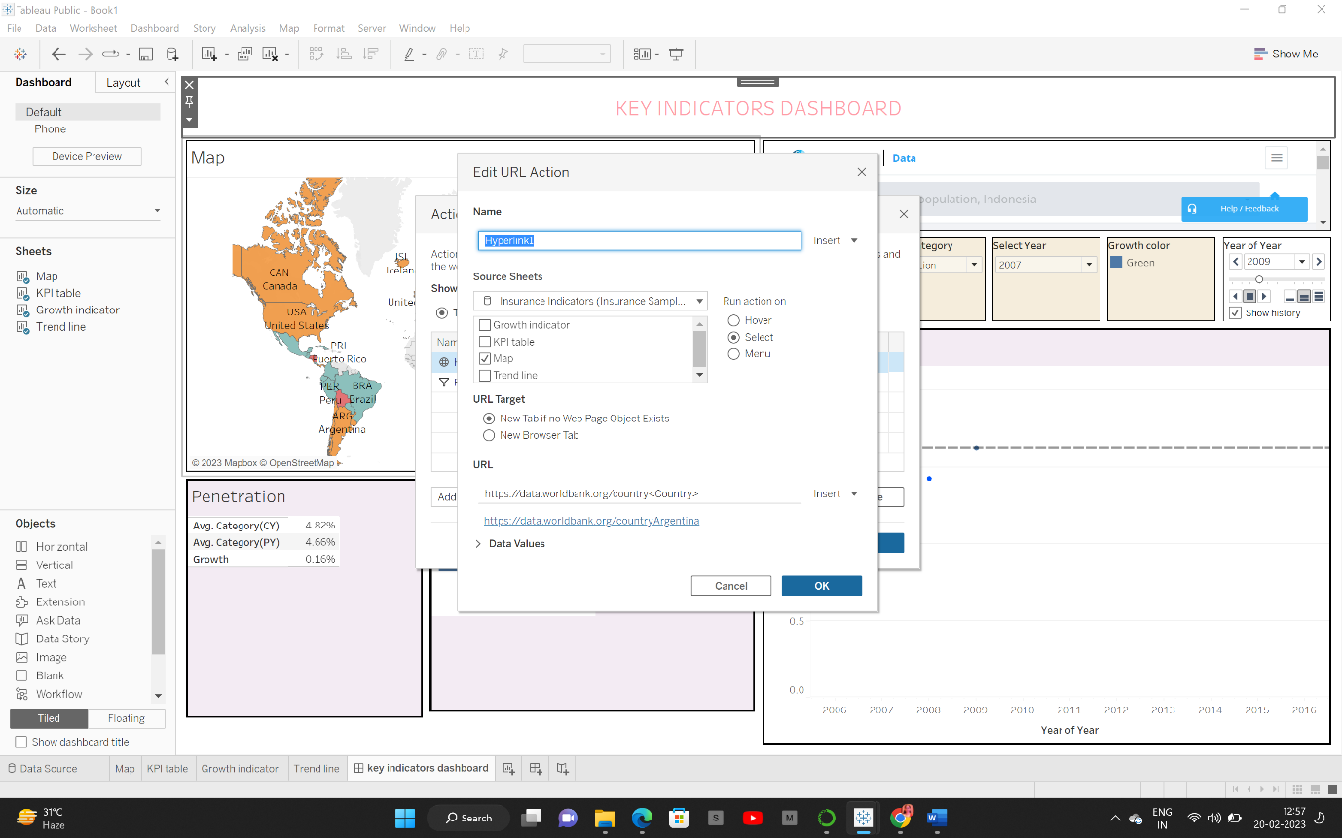

Go to Object , the drag Horizontal Tab again.

Click on Floating -> add KPI sheet, Growth Indicator sheet and Trend Chart sheet and rearrange it.

Then click on Select Income Filter -> More options -> Apply to Worksheets -> Selected worksheet -> click on All on Dashboard.

Then click on Dashboard -> click on actions -> add action -> filter-> edit filter -> source sheet -> KPI table Target sheet-> All except KPI table Run on action -> Click on Select. 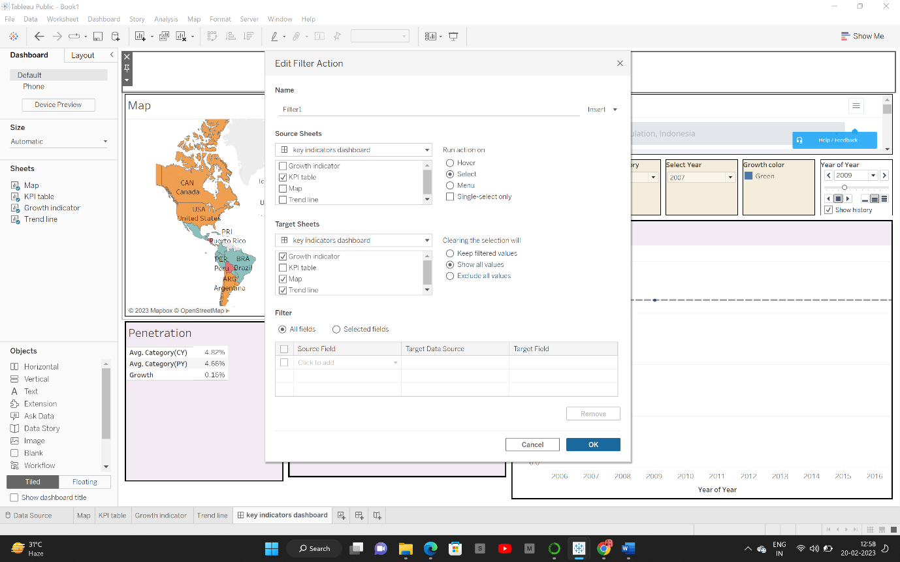

COMPLETE DASHBOARD

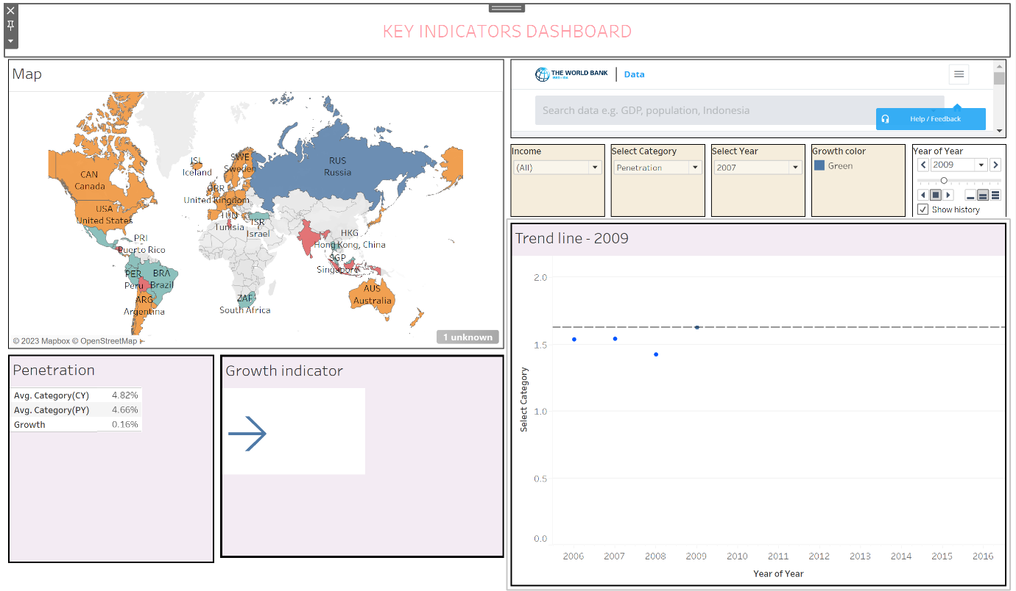

Dashboard link: https://public.tableau.com/app/profile/harika.hanumanthu/viz/Keyindicatorsdashboard_16769085415720/keyindicatorsdashboard

Thank you